# CITP 155 – Programming I

## Classes Lab

## Graded Activity (20 points)

Provide any screen shots using the Snipping Tool and selecting only the relevant portion of the screen (instead of the entire screen). Provide any answers using a blue font. Please note that part of being a good programmer is being precise. If you have typos in your code, such as the words that are supposed to be displayed, you will not receive full credit.

KEEP ALL OF YOUR SOLUTION AND PROJECT FILES THROUGHOUT THE DURATION OF THE CLASS!

Concepts taken from the online C# tutorial <https://csharp.net-tutorials.com/>

**Create a New Visual Studio Visual C# Console Application Project (1 point)**

Project Name: Multiplication

Location: c:\users\student\documents\visual studio 2015\Projects\LastName_FirstName

Solution Name: Math

Provide a screen shot of the New Project screen before clicking OK.

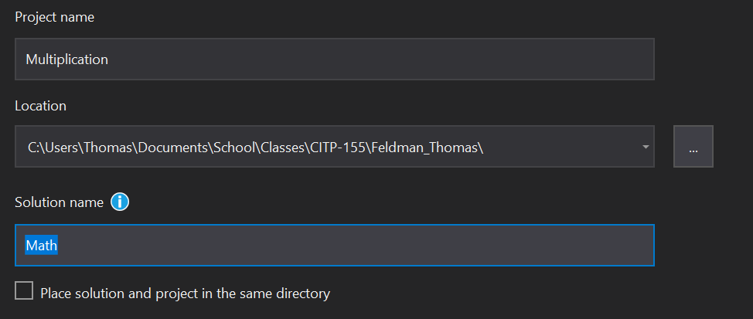

**Open and Modify Your C# Program**

Using the coding examples found in the “Classes” section of <https://csharp.net-tutorials.com/> and the example we did together in class as a guide, create a program that does the following:

* In the Main method
  + Declare four variables with data types of int.
  + Name the variables: numberOne, numberTwo, numberThree, numberFour.
  + Assign the values to the variables (in this order): 2, 5,3, 10.
* Create a class named Multiply. This is a non-static class.
* The Multiply class should have three static instances of a method named Calculate.
  + The first Calculate method will accept two integers: numberOne and numberTwo.  
    The method will call the Calculate method that accepts three integers. It will pass numberOne, numberTwo, and a 1.  
    The method will simply return the results of this call to whatever called it.
  + The second Calculate method will accept three integers: numberOne, numberTwo, and numberThree.
  + The method will call the Calculate method that accepts four integers. It will pass numberOne, numberTwo, numberThree, and a 1.  
    The method will simply return the results of this call to whatever called it.
  + The third Calculate method will accept four integers: numberOne, numberTwo, numberThree, and numberFour.  
    The method will return the results of multiplying all four of the integers together. The symbol for multiplication is * (an asterisk).

* In the Main method
  + Declare a variable named returnedValue. It is an int.
  + Set the returnedValue variable equal to a call to the Calculate method that accepts two integers. Pass in numberOne and numberTwo as the values.
  + Write the returnedValue variable to the console.
  + Set the returnedValue variable equal to a call to the Calculate method that accepts three integers. Pass in numberOne, numberTwo, and numberThree as the values.
  + Write the returnedValue variable to the console.
  + Set the returnedValue variable equal to a call to the Calculate method that accepts four integers. Pass in numberOne, numberTwo, numberThree, and numberFour as the values.
  + Write the returnedValue variable to the console.
* Make sure the console pauses at the end so the messages can be read by the end user.
* Test your program.
* The results should be three numbers displayed to the console. The numbers should be 10, 30, 300. These are the answers to the multiplication problems:  
  2 * 5 = 10  
  2 * 5 * 3 = 30  
  2 * 5 * 3 * 10 = 300

**Using Other Skills (4 points)**

We have covered the concept of Namespaces this week. We have also covered IntelliSense. Use the steps you learned from the IntelliSense worksheet and the chapter reading to remove unnecessary using statements in your program. After you expand the menus to perform this step, take a screen shot using the print screen button on your keyboard before clicking the last step to remove the usings. After securing your screen shot, go ahead and click to remove the unnecessary usings.

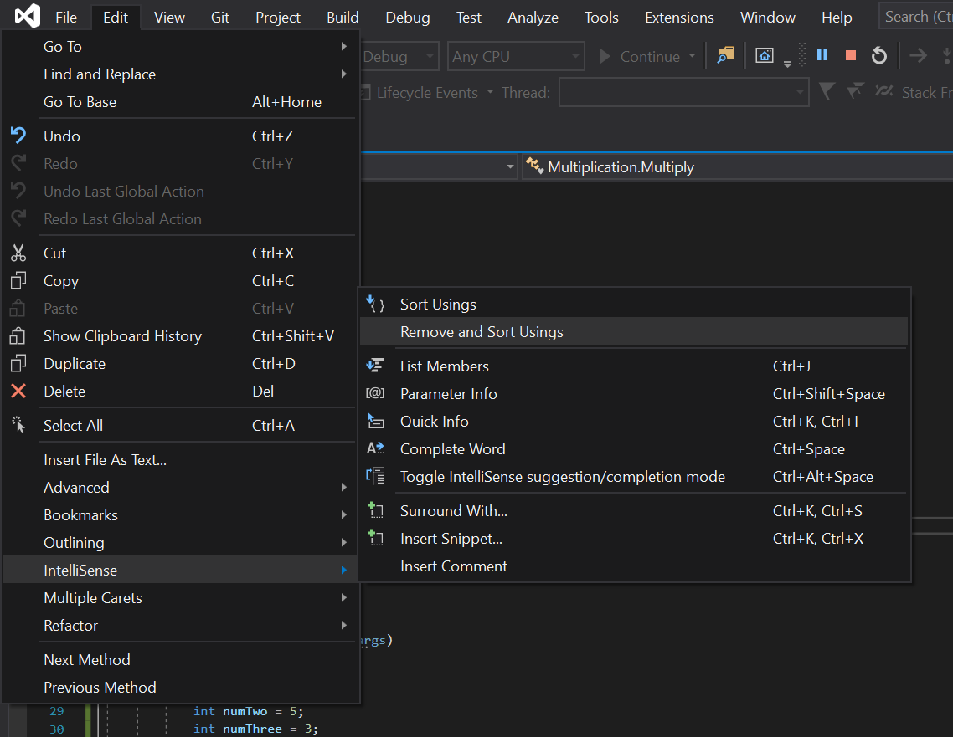

Another skill you learned when studying intelliSense is braces matching. Place your cursor in an appropriate position in your program (either right after or right before) a brace. Notice how the beginning and ending braces that belong together are highlighted. Use the Snipping Tool to take a screen shot of the highlighted pair.

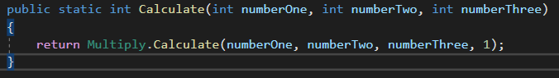

**Provide Results (15 points)**

Test the program (run the debugger).

Provide a screen shot of your testing. The screen shot should include the title bar of the console with the full path of the program and three lines of white text.

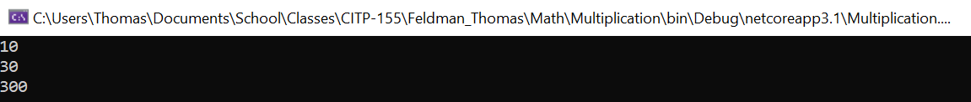

Copy and paste the lines of code from your program here. This is not a screen shot. This is code I can copy and paste to run on my own. This should be 45-55 lines of code, depending on how many blank lines you left in between other lines of code.

using System;

namespace Multiplication

{

class Multiply

{

public static int Calculate(int numberOne, int numberTwo, int numberThree, int numberFour)

{

return numberOne * numberTwo * numberThree * numberFour;

}

public static int Calculate(int numberOne, int numberTwo)

{

return Multiply.Calculate(numberOne, numberTwo, 1);

}

public static int Calculate(int numberOne, int numberTwo, int numberThree)

{

return Multiply.Calculate(numberOne, numberTwo, numberThree, 1);

}

}

class Program

{

static void Main(string[] args)

{

int returnedValue = 1;

int numOne = 2;

int numTwo = 5;

int numThree = 3;

int numFour = 10;

returnedValue = Multiply.Calculate(numOne, numTwo);

Console.WriteLine(returnedValue);

returnedValue = Multiply.Calculate(numOne, numTwo, numThree);

Console.WriteLine(returnedValue);

returnedValue = Multiply.Calculate(numOne, numTwo, numThree, numFour);

Console.WriteLine(returnedValue);

Console.ReadLine();

}

}

}